Alert Watch and Response Engine (AWARE)

Test Account Installation, Setup and Startup Manual



February 2014

Prepared by Harris Corporation

Revision History

| Creation Date | Version No. | Description/Comments | Author(s) | Reviewer(s) | Review Type | Issue Date |
| --- | --- | --- | --- | --- | --- | --- |
| 11/12/2013 | 0.01 | Updated version of the Astronaut’s Alert Reengineering Installation, Setup and Startup Manual | I. Valdes  B. Tjahjo |  |  |  |
|  |  |  |  |  |  |  |
|  |  |  |  |  |  |  |
|  |  |  |  |  |  |  |
|  |  |  |  |  |  |  |

Table of Contents

1 Introduction 1

1.1 Preparation 1

2 Installation 1

2.1 Load and install the VEFA_ALRE_1_1.KID file 1

2.1.1 Define OCCULT BLOOD and PROSTATE SPECIFIC ANTIGEN lab data 4

2.2 Load and install the VEFA_ALRE_1_2.KID file 5

3 Setup Knowledge Based Rule 8

3.1 Import "Setup Helper" routine 8

3.2 Run Part 1 of "Setup Helper" routine 9

3.3 Install all AVEFA1 and AVEFA2 Reminder Exchange entries 10

3.4 Remove disabled/Non-active AVEFA Reminder Dialogs 14

3.5 Run Part 2 of "Setup Helper" routine 16

3.6 Edit procedure, consult, lab, or pharmacy Orderable Item preceding previous name with **"**VEFA” 17

3.7 Run Part 3 of "Setup Helper" routine 21

4 Startup User Guide 22

4.1 Setup CPRS for using FAT COM Object 22

4.2 Setup "Patient Closeout Chart" COM object 23

4.3 Assign VEFAALRE RPC context option to users 24

4.4 Reminder Dialog and TIU Template Linkage 25

4.5 Enable notification for Critical lab result, abnormal Image results, etc 26

5 Testing 28

5.1 Generating Critical Lab and Abnormal Imaging Result Alerts 28

5.2 Testing for Follow-up actions upon Patient Chart Closeout 32

5.2.1 Prompting for Follow-up action through directed appropriate Reminder Dialog or Signing orders to complete Follow-up actions 32

5.3 Testing with Alert Acknowledge/Deletion with an Auto-Renewal 40

# Introduction

This document provides KIDS installation guide, setup Knowledge-Based rules guide and a startup user guide. All sections can be performed by an IRM programmer or Clinical Coordinator.

The installation, setup and startup guides are intended to be used in a test account environment.

## Preparation

Place all KIDS files, reminder exchanges files and routine files provided on a temporary folder (i.e.: C:\AWARE).

The four Reminder Exchanges files are the 4 example Reminder Dialogs associated with 4 types of alerts with Follow-up Action Tracking (FAT).

Additional alert creation test programs for critical lab and abnormal imaging results are provided through additional routines (.RTN) and KIDS files.

# Installation

## 2.1 Load and install the VEFA_ALRE_1_1.KID file

Select OPTION NAME: **XPD INSTALLATION MENU** Installation

**1 Load a Distribution**

2 Verify Checksums in Transport Global

3 Print Transport Global

4 Compare Transport Global to Current System

5 Backup a Transport Global

6 Install Package(s)

Restart Install of Package(s)

Unload a Distribution

Select Installation Option: **1 Load a Distribution**

Enter a Host File: **C:\AWARE\VEFA_ALRE_1_1.KID**

KIDS Distribution saved on Sep 01, 2011@16:30:06

Comment: VEFA ALRE 1.1

This Distribution contains Transport Globals for the following Package(s):

VEFA1 1.1

Distribution OK!

Want to Continue with Load? YES//

Loading Distribution...

VEFA1 1.1

Use INSTALL NAME: VEFA1 1.1 to install this Distribution.

1 Load a Distribution

**2 Verify Checksums in Transport Global**

3 Print Transport Global

4 Compare Transport Global to Current System

5 Backup a Transport Global

6 Install Package(s)

Restart Install of Package(s)

Unload a Distribution

Select Installation Option: **VERify Checksums in Transport Global**

Select INSTALL NAME: VEFA1 1.1 Loaded from Distribution 9/1/11@17:09:41

=> VEFA ALRE 1.1 ;Created on Sep 01, 2011@16:30:06

This Distribution was loaded on Sep 01, 2011@17:09:41 with header of

VEFA ALRE 1.1 ;Created on Sep 01, 2011@16:30:06

It consisted of the following Install(s):

VEFA1 1.1

Want each Routine Listed with Checksums: Yes// **YES**

DEVICE: HOME// TELNET PORT

PACKAGE: VEFA1 1.1 Sep 01, 2011 5:09 pm PAGE 1

-------------------------------------------------------------------------------

0 Routine checked, 0 failed.

1 Load a Distribution

2 Verify Checksums in Transport Global

3 Print Transport Global

4 Compare Transport Global to Current System

5 Backup a Transport Global

**6 Install Package(s)**

Restart Install of Package(s)

Unload a Distribution

Select Installation Option**: INStall Package(s)**

Select INSTALL NAME: VEFA1 1.1 Loaded from Distribution 9/1/11@17:09:41

=> VEFA ALRE 1.1 ;Created on Sep 01, 2011@16:30:06

This Distribution was loaded on Sep 01, 2011@17:09:41 with header of

VEFA ALRE 1.1 ;Created on Sep 01, 2011@16:30:06

It consisted of the following Install(s):

VEFA1 1.1

Checking Install for Package VEFA1 1.1

Install Questions for VEFA1 1.1

Incoming Files:

101.43 ORDERABLE ITEMS (including data)

Note: You already have the 'ORDERABLE ITEMS' File.

I will OVERWRITE your data with mine.

Want KIDS to INHIBIT LOGONs during the install? **NO//**

Want to DISABLE Scheduled Options, Menu Options, and Protocols? **NO//**

Enter the Device you want to print the Install messages.

You can queue the install by enter a 'Q' at the device prompt.

Enter a '^' to abort the install.

DEVICE: HOME//**<RET>** TELNET PORT

VEFA1 1.1

Oct 28, 2013@08:19:36

Installing Data Dictionaries:

Oct 28, 2013@08:19:36

Installing Data:

Oct 28, 2013@08:19:36

Updating Routine file...

Updating KIDS files...

VEFA1 1.1 Installed.

Oct 28, 2013@08:19:36

No link to PACKAGE file

NO Install Message sent

100% 

Complete

Install Completed

Define OCCULT BLOOD and PROSTATE SPECIFIC ANTIGEN lab data names in ^DD(63.04) array as needed (unless already exist).

>D P^DI

VA FileMan 22.0

Select OPTION**: ?**

Answer with OPTION NUMBER, or NAME

Choose from:

1 ENTER OR EDIT FILE ENTRIES

2 PRINT FILE ENTRIES

3 SEARCH FILE ENTRIES

**4 MODIFY FILE ATTRIBUTES**

5 INQUIRE TO FILE ENTRIES

6 UTILITY FUNCTIONS

7 OTHER OPTIONS

8 DATA DICTIONARY UTILITIES

9 TRANSFER ENTRIES

Select OPTION: **4 MODIFY FILE ATTRIBUTES**

Do you want to use the screen-mode version? YES// NO

MODIFY WHAT FILE: PROTOCOL// **LAB DATA** (0 entries)

Select FIELD: **4 CHEM, HEM, TOX, RIA, SER, etc. (multiple)**

LABEL: CHEM, HEM, TOX, RIA, SER, etc.//

READ ACCESS (OPTIONAL):

WRITE ACCESS (OPTIONAL):

SOURCE:

Select DESTINATION:

Select GROUP:

DESCRIPTION:

1>Multiple field for Chem., Hem., Tox., RIA, Ser., etc. results

EDIT Option:

TECHNICAL DESCRIPTION:

1>

Select CHEM, HEM, TOX, RIA, SER, etc. SUB-FIELD: **500027** **🡨--- enter if not already exist**

Are you adding

a new CHEM, HEM, TOX, RIA, SER, etc. SUB-FIELD (the 860TH)? No// **Y (Yes)**

LABEL: **OCCULT BLOOD**

CHEM, HEM, TOX, RIA, SER, etc. SUB-FIELD NUMBER: 500027//

DATA TYPE OF OCCULT BLOOD: **FREE TEXT**

MINIMUM LENGTH: **1**

MAXIMUM LENGTH: **8**

(OPTIONAL) PATTERN MATCH (IN 'X'):

WILL OCCULT BLOOD FIELD BE MULTIPLE? No**// (No)**

SUBSCRIPT: 49// **500027**

^-PIECE POSITION**: 1//**

IS OCCULT BLOOD ENTRY MANDATORY (Y/N): NO**// NO**

....

'HELP'-PROMPT: Answer must be 1-8 characters in length.

Replace

XECUTABLE 'HELP':

DESCRIPTION:

1>

Select CHEM, HEM, TOX, RIA, SER, etc. SUB-FIELD: **500039** **🡨--- enter if not already exist**

Are you adding

a new CHEM, HEM, TOX, RIA, SER, etc. SUB-FIELD (the 861ST)? No// **Y (Yes)**

LABEL: **PROSTHETIC SPECIFIC ANTIGEN**

CHEM, HEM, TOX, RIA, SER, etc. SUB-FIELD NUMBER: 500039//

DATA TYPE OF PROSTHETIC SPECIFIC ANTIGEN: **NUMERIC**

INCLUSIVE LOWER BOUND: **0**

INCLUSIVE UPPER BOUND: **99999**

IS THIS A DOLLAR AMOUNT (Y/N): **NO//**

MAXIMUM NUMBER OF FRACTIONAL DIGITS: **0//**

WILL PROSTHETIC SPECIFIC ANTIGEN FIELD BE MULTIPLE? **No// (No)**

SUBSCRIPT: 49// **500039**

^-PIECE POSITION: 1//

IS PROSTHETIC SPECIFIC ANTIGEN ENTRY MANDATORY (Y/N**): NO**

// NO

....

'HELP'-PROMPT: Type a number between 0 and 99999, 0 decimal digits.

Replace

XECUTABLE 'HELP':

DESCRIPTION:

1>

## 2.2 Load and install the VEFA_ALRE_1_2.KID file

Select OPTION NAME: **XPD INSTALLATION MENU** Installation

**1 Load a Distribution**

2 Verify Checksums in Transport Global

3 Print Transport Global

4 Compare Transport Global to Current System

5 Backup a Transport Global

6 Install Package(s)

Restart Install of Package(s)

Unload a Distribution

Select Installation Option: **1 Load a Distribution**

Enter a Host File: **C:\AWARE\VEFA_ALRE_1_2.KID**

KIDS Distribution saved on Aug 20, 2011@12:48:43

Comment: VEFA ALERTS RE-ENGINEERING

This Distribution contains Transport Globals for the following Package(s):

VEFA ALRE 1.2

Distribution OK!

Want to Continue with Load? **YES//**

Loading Distribution...

VEFA ALRE 1.2

Use INSTALL NAME: VEFA ALRE 1.2 to install this Distribution.

1 Load a Distribution

2 Verify Checksums in Transport Global

3 Print Transport Global

4 Compare Transport Global to Current System

5 Backup a Transport Global

**6 Install Package(s)**

Restart Install of Package(s)

Unload a Distribution

Select Installation Option: **INStall Package(s)**

Select INSTALL NAME: **VEFA ALRE 1.2** Loaded from Distribution 8/28/11@14:4

7:39

=> VEFA ALRE 1.2 ;Created on Aug 28, 2011@12:33:45

This Distribution was loaded on Aug 28, 2011@14:47:39 with header of

VEFA ALRE 1.2 ;Created on Aug 28, 2011@12:33:45

It consisted of the following Install(s):

VEFA ALRE 1.2

Checking Install for Package VEFA ALRE 1.2

Install Questions for VEFA ALRE 1.2

Incoming Files:

60 LABORATORY TEST (including data)

Note: You already have the 'LABORATORY TEST' File.

I will OVERWRITE your data with mine.

101.15 OE/RR COM OBJECTS (including data)

Note: You already have the 'OE/RR COM OBJECTS' File.

I will OVERWRITE your data with mine.

101.41 ORDER DIALOG (including data)

Note: You already have the 'ORDER DIALOG' File.

I will OVERWRITE your data with mine.

101.43 ORDERABLE ITEMS (including data)

Note: You already have the 'ORDERABLE ITEMS' File.

I will OVERWRITE your data with mine.

19007 VEFA Tracked Critical Alert (including data)

19008 VEFA CRITICAL ALERT CATEGORY (including data)

9999999.64HEALTH FACTORS (including data)

Note: You already have the 'HEALTH FACTORS' File.

I will OVERWRITE your data with mine.

Want KIDS to Rebuild Menu Trees Upon Completion of Install? NO//

Want KIDS to INHIBIT LOGONs during the install? NO//

Want to DISABLE Scheduled Options, Menu Options, and Protocols? NO//

Enter the Device you want to print the Install messages.

You can queue the install by enter a 'Q' at the device prompt.

Enter a '^' to abort the install.

DEVICE: HOME// CONSOLE

VEFA ALRE 1.2

Installing REMOTE PROCEDURE

Installing OPTION

Installing PARAMETER DEFINITION

Oct 28, 2013@10:14:57

Updating Routine file...

Updating KIDS files...

VEFA ALRE 1.2 Installed.

Oct 28, 2013@10:14:57

No link to PACKAGE file

NO Install Message sent

100% 

Complete

Install Completed

# Setup Knowledge Based Rule

Knowledge Based rule file is the core of alert tracking function. This rule consists of Reminder Dialogs and TIU template that physician will use to perform follow-up action. The following guide shows you how to load and install the “pre-made” Reminder dialogs. Setup helper routine is created to automate some of the process in setting up the “Knowledge Based” rule.

## 3.1 Import Setup Helper Routine

**>D ^%RI**

Input routines from Sequential

Device: **C:\Aware\VEFAINST.RTN**

Parameters? "RS" =>

File written by Cache for Windows using %RO on 28 Oct 2013 11:10 AM

with extension INT and with description:

( All Select Enter List Quit )

Routine Input Option: **All Routines**

If a selected routine has the same name as one already on file,

shall it replace the one on file? No => Yes

Recompile? Yes => Yes

Display Syntax Errors? Yes => Yes

^ indicates routines which will replace those now on file.

@ indicates routines which have been [re]compiled.

- indicates routines which have not been filed.

VEFAINST.INT^@ VEFAVER.INT^@

2 routines processed.

## Run Part 1 of Setup Helper Routine

This part of Setup helper routine will remove duplicate entries in orderable items and load the “pre-made” Reminder Exchange files. Other routines used for testing purposes will also be loaded and compiled at this time.

>**D EN^VEFAINST("C:\Aware\")**

PRE AWARE SETUP

===============

Delete multiple entries in orderable items: *OK*

Delete multiple entries in orderable items: *OK*

Loading host file C:\Aware\AVEFA1_PSA.PRD

Host file C:\Aware\AVEFA1_PSA.PRD successfully loaded.

Loading host file C:\Aware\AVEFA1_FOBT-FIT.PRD

Host file C:\Aware\AVEFA1_FOBT-FIT.PRD successfully loaded.

Loading host file C:\Aware\AVEFA1_ABNORMAL_CXR.PRD

Host file C:\Aware\AVEFA1_ABNORMAL_CXR.PRD successfully loaded.

Loading host file C:\Aware\AVEFA1_ABNORMAL_MAMMOGRAM.PRD

Host file C:\Aware\AVEFA1_ABNORMAL_MAMMOGRAM.PRD successfully loaded.

Load started on 10/28/2013 11:22:57

Loading file C:\Aware\ZSTUINNO.RTN as rtn

ZSTU.INT Loaded

Compiling routine : ZSTU.INT

Load finished successfully.

C:\Aware\ZSTUINNO.RTN loaded. *OK*

Load started on 10/28/2013 11:22:57

Loading file C:\Aware\ZVH.RTN as rtn

LRZORD.INT Loaded

ZVHDPT.INT Loaded

ZVHGMPL.INT Loaded

ZVHGMPLZVHU.INT Loaded

ZVHGMPOP.INT Loaded

ZVHGMRV.INT Loaded

ZVHLRXOR.INT Loaded

ZVHPSORD.INT Loaded

ZVHTREATFAC.INT Loaded

ZVHZSDM.INT Loaded

Compiling routine : LRZORD.INT

Compiling routine : ZVHDPT.INT

Compiling routine : ZVHGMPOP.INT

Compiling routine : ZVHGMPLZVHU.INT

Compiling routine : ZVHGMPL.INT

Compiling routine : ZVHGMRV.INT

Compiling routine : ZVHLRXOR.INT

Compiling routine : ZVHTREATFAC.INT

Compiling routine : ZVHPSORD.INT

Compiling routine : ZVHZSDM.INT

Load finished successfully.

C:\Aware\ZVH.RTN loaded. *OK*

Make sure OCCULT BLOOD and PROSTATE SPECIFIC ANTIGEN in Laboratory Test file

have the correct Institution

## Install all AVEFA1 and AVEFA2 Reminder Exchange entries

Select OPTION NAME: **PXRM REMINDER EXCHANGE** Reminder Exchange

Reminder Exchange

Clinical Reminder Exchange Oct 28, 2013@14:54:44 Page: 1 of 14

Exchange File Entries.

Item Entry Source Date Packed

1 AVEFA1 ABNORMAL CXR PROGRAMMER@CAMP MASTER 08/27/2011@11:10

2 AVEFA1 ABNORMAL MAMMOGRAM PROGRAMMER@CAMP MASTER 08/27/2011@11:14

3 AVEFA2 FOBT-FIT PROGRAMMER@CAMP MASTER 08/30/2011@00:38

4 AVEFA2 PSA PROGRAMMER@CAMP MASTER 08/30/2011@00:32

5 BDI II RESULT GROUP PULEO@SALT LAKE CI 04/13/2004@15:53

6 DEPRESSION/PTSD REMINDER TERM VOLPP@NORTHERN CAL 02/26/2010@12:07

UPDATES - PATCH 17

7 GMTS SKIN RISK HS OBJECTS PULEO@SALT LAKE CI 07/09/2007@13:21

8 GMTS SKIN RISK HS TYPES PULEO@SALT LAKE CI 07/09/2007@13:20

9 GMTSMHV PULEO@SALT LAKE CI 07/06/2004@15:06

+ + Next Screen - Prev Screen ?? More Actions >>>

CFE Create Exchange File Entry IH Installation History

CHF Create Host File LHF Load Host File

CMM Create MailMan Message LMM Load MailMan Message

DFE Delete Exchange File Entry LR List Reminder Definitions

IFE Install Exchange File Entry RI Reminder Definition Inquiry

Select Action: Next Screen// **IFE Install Exchange File Entry**

Select Entry(s): (1-9): **1**

Exchange File Components Oct 28, 2013@15:07:24 Page: 1 of 8

Component Category Exists

Source: PROGRAMMER,ONE at CAMP MASTER

Date Packed: 08/27/2011@11:10:07

Package Version: 2.0P12

Description:

ABNORMAL CHEST X-RAY,CXR

Non-exchangeable order dialog(s):

-------------------------------------------------------------------------------

Name: VEFA RA58 Chest PA&LAT

Type: Quick Order

Display Text: Chest PA&LAT

Display Group: GENERAL RADIOLOGY

Package: RADIOLOGY/NUCLEAR MEDICINE

Procedure: VEFA CHEST 2 VIEWS PA&LAT

Urgency: ROUTINE

Submit request to: RADIOLOGY MAIN FLOOR

+ Enter ?? for more actions >>>

IA Install all Components IS Install Selected Component

Select Action: Next Screen//**IA Install all Components**

HEALTH FACTORS entry named REMINDER FACTORS already exists and the

packed component is identical, skipping.

HEALTH FACTORS entry named VEFA OTHER FOLLOW-UP COMMENTS already

exists and the packed component is identical, skipping.

HEALTH FACTORS entry named VEFA PAT OPTED NO TREA already exists and

the packed component is identical, skipping.

HEALTH FACTORS entry named VEFA PAT NO LONGER IN CARE already exists

and the packed component is identical, skipping.

HEALTH FACTORS entry named VEFA LIMITED LIFE already exists and the

packed component is identical, skipping.

HEALTH FACTORS entry named VEFA FOLLOWUP already exists and the

packed component is identical, skipping.

HEALTH FACTORS entry named VEFA REFER TO ANOTHER VA PROV already

exists and the packed component is identical, skipping.

HEALTH FACTORS entry named VEFA DISCUSSED WITH PAT already exists and

the packed component is identical, skipping.

HEALTH FACTORS entry named VEFA CARDIOTHORACIC SURG CSLT already

exists and the packed component is identical, skipping.

HEALTH FACTORS entry named VEFA CHEST X-RAY NO FINDINGS already exists

and the packed component is identical, skipping.

HEALTH FACTORS entry named VEFA ORDER HEME-ONC CONSULT already exists

and the packed component is identical, skipping.

HEALTH FACTORS entry named VEFA ORDER CHEST BIOPSY already exists and

the packed component is identical, skipping.

HEALTH FACTORS entry named VEFA ORDER PULMONOLOGY CONSULT already

exists and the packed component is identical, skipping.

HEALTH FACTORS entry named VEFA REPEAT CXR already exists and the

packed component is identical, skipping.

HEALTH FACTORS entry named VEFA ORDER CT CHEST already exists and the

packed component is identical, skipping.

Dialog Components Oct 28, 2013@15:19:40 Page: 1 of 4

Packed reminder dialog: AVEFA ABNORMAL CXR

Item Seq. Dialog Findings Type Exists

1 AVEFA ABNORMAL CXR dialog

2 1 AVEFA ABNORMAL CXR GROUP group

Finding: *NONE*

3 1..5 AVEFA CXR CHEST X-RAY NO FINDINGS element

Add. Finding: VEFA CHEST X-RAY NO FINDINGS (HEALTH FACTOR) X

4 1.1 AVEFA CXR ORDER CT CHEST element

Finding: VEFA RA CT CHEST (ORDER DIALOG) X

Add. Finding: VEFA ORDER CT CHEST (HEALTH FACTOR) X

5 1.2 AVEFA CXR REPEAT CXR element

Finding: VEFA RA58 Chest PA&LAT (ORDER DIALOG) X

Add. Finding: VEFA REPEAT CXR (HEALTH FACTOR) X

6 1.3 AVEFA CXR ORDER PULMONOLOGY CONSULT element

Finding: VEFA GMRCT PULMONARY (ORDER DIALOG) X

Add. Finding: VEFA ORDER PULMONOLOGY CONSULT (HEALTH FACTOR) X

+ + Next Screen - Prev Screen ?? More Actions

DD Dialog Details DT Dialog Text IS Install Selected

DF Dialog Findings DU Dialog Usage QU Quit

DS Dialog Summary IA Install All

Select Action: Next Screen//**IA Install All**

All dialog components for AVEFA ABNORMAL CXR are new.

Install reminder dialog and all components with no further changes: **Y// ES**

REMINDER DIALOG entry named PXRM COMMENT already exists and the

packed component is identical, skipping.

REMINDER DIALOG entry named AVEFA OTHER FOLLOW-UP COMMENTS already

exists and the packed component is identical, skipping.

REMINDER DIALOG entry named AVEFA OTHER FOLLOWUP COMMENTS GROUP

already exists and the packed component is identical, skipping.

REMINDER DIALOG entry named AVEFA PAT OPTED NO TREAT already exists

and the packed component is identical, skipping.

REMINDER DIALOG entry named AVEFA PAT NO LONGER IN CARE already exists

and the packed component is identical, skipping.

REMINDER DIALOG entry named AVEFA LIMITED LIFE already exists and the

packed component is identical, skipping.

REMINDER DIALOG entry named AVEFA FOLLOWUP already exists and the

packed component is identical, skipping.

REMINDER DIALOG entry named AVEFA REFER TO ANOTHER VA PROV already

exists and the packed component is identical, skipping.

REMINDER DIALOG entry named AVEFA DISCUSSED WITH PAT already exists

and the packed component is identical, skipping.

REMINDER DIALOG entry named AVEFA OTHER FOLLOW-UP GROUP already exists

and the packed component is identical, skipping.

REMINDER DIALOG entry named AVEFA CXR CARDIO-THORACIC SURG CSLT

already exists and the packed component is identical, skipping.

REMINDER DIALOG entry named AVEFA CXR ORDER HEME-ONC CONSULT already

exists and the packed component is identical, skipping.

REMINDER DIALOG entry named AVEFA CXR ORDER CHEST BIOPSY already

exists and the packed component is identical, skipping.

REMINDER DIALOG entry named AVEFA CXR ORDER PULMONOLOGY CONSULT

already exists and the packed component is identical, skipping.

REMINDER DIALOG entry named AVEFA CXR REPEAT CXR already exists and

the packed component is identical, skipping.

REMINDER DIALOG entry named AVEFA CXR ORDER CT CHEST already exists

and the packed component is identical, skipping.

REMINDER DIALOG entry named AVEFA CXR CHEST X-RAY NO FINDINGS already

exists and the packed component is identical, skipping.

REMINDER DIALOG entry named AVEFA ABNORMAL CXR GROUP already exists

and the packed component is identical, skipping.

Reminder Dialog AVEFA ABNORMAL CXR is not linked to a reminder.

Select Reminder to Link:

Repeat step 3.3 above for the remainder AVEFA1 and AVEFA2 Reminder Exchange entries.

## Remove disabled/Non-active AVEFA Reminder Dialogs

Select OPTION NAME: **PXRM DIALOG MANAGEMENT** Reminder Dialog Management

DP Dialog Parameters ...

**DI Reminder Dialogs**

DR Dialog Reports ...

IA Inactive Codes Mail Message

Select Reminder Dialog Management Option: **DI Reminder Dialogs**

Dialog List Oct 28, 2013@17:15:44 Page: 1 of 7

REMINDER VIEW (ALL REMINDERS BY NAME)

Item Reminder Name Linked Dialog Name & Dialog Status

1 PATCH 11 LOCATION LIST

2 VA-*IHD 412 ELEVATED LDL REPORTING

3 VA-*IHD 412 LIPID PROFILE REPORTIN

4 VA-*IHD ELEVATED LDL REPORTING

5 VA-*IHD LIPID PROFILE REPORTING

6 VA-AAA SCREENING VA-AAA SCREENING

7 VA-ALCOHOL AUDIT-C POSITIVE F/U EV VA-ALCOHOL F/U POS AUDIT-C

8 VA-ALCOHOL USE SCREEN (AUDIT-C) VA-ALCOHOL USE SCREENING (A

9 VA-ANTIPSYCHOTIC MED SIDE EFF EVAL VA-AIMS

10 VA-BL ALCOHOL SCREEN

11 VA-BL ALCOHOL WITHIN SAFE LIMIT

12 VA-BL DEPRESSION SCREEN

13 VA-BL OEF/OIF EMBEDDED FRAGMENTS

14 VA-BL OEF/OIF FEVER

15 VA-BL OEF/OIF GI SX

16 VA-BL OEF/OIF OTHER SX

+ Enter ?? for more actions >>>

AR All reminders LR Linked Reminders QU Quit

CV Change View RN Name/Print Name

Select Item: Next Screen// **CV Change View**

TYPE OF VIEW: R//**D Reminder Dialogs**

Dialog List Oct 28, 2013@17:18:33 Page: 1 of 3

DIALOG VIEW (REMINDER DIALOGS - SOURCE REMINDER NAME)

Item Reminder Dialog Name Source Reminder Status

1 AVEFA ABNORMAL CXR *NONE* Disabled

2 AVEFA ABNORMAL MAMMOGRAM *NONE* Disabled

3 AVEFA FOBT-FIT *NONE* Disabled

4 AVEFA PSA *NONE* Disabled

5 VA-AAA SCREENING *NONE* Linked

6 VA-AIMS VA-ANTIPSYCHOTIC MED SIDE Linked

7 VA-ALCOHOL F/U POS AUDIT-C *NONE* Linked

8 VA-ALCOHOL USE SCREENING (AUDIT-C) *NONE* Linked

9 VA-DEPRESSION ASSESSMENT VA-POS DEPRESSION SCREEN Disabled

10 VA-DEPRESSION SCREEN VA-DEPRESSION SCREENING Linked

11 VA-EMBEDDED FRAGMENTS RISK EVALUATION *NONE* Linked

12 VA-EMBEDDED FRAGMENTS SCREENING *NONE* Linked

13 VA-GEC REFERRAL CARE COORDINATION VA-GEC REFERRAL CARE COOR Linked

14 VA-GEC REFERRAL CARE RECOMMENDATION VA-GEC REFERRAL CARE RECO Linked

15 VA-GEC REFERRAL NURSING ASSESSMENT VA-GEC REFERRAL NURSING A Linked

16 VA-GEC REFERRAL SOCIAL SERVICES VA-GEC REFERRAL SOCIAL SE Linked

+ + Next Screen - Prev Screen ?? More Actions >>>

AD Add Reminder Dialog PT List/Print All QU Quit

CV Change View RN Name/Print Name

Select Item: Next Screen// **1**

**Dialog List** Sep 01, 2011@00:45:24 Page: 1 of 4

DIALOG VIEW (REMINDER DIALOGS - SOURCE REMINDER NAME)

Item Reminder Dialog Name Source Reminder Status

1 ARD 227H ANTICOAGULATION FOR AFIB ARD 00 ANTICOAGULATION AF

2 AVEFA ABNORMAL CXR *NONE*

Dialog Edit List Oct 28, 2013@17:21:29 Page: 1 of 3

REMINDER DIALOG NAME: AVEFA ABNORMAL CXR (Disabled)

Item Seq. Dialog Summary

1 1 Group: AVEFA ABNORMAL CXR GROUP

2 1..5 Element: AVEFA CXR CHEST X-RAY NO FINDINGS

3 1.1 Element: AVEFA CXR ORDER CT CHEST

4 1.2 Element: AVEFA CXR REPEAT CXR

5 1.3 Element: AVEFA CXR ORDER PULMONOLOGY CONSULT

6 1.4 Element: AVEFA CXR ORDER CHEST BIOPSY

7 1.5 Element: AVEFA CXR ORDER HEME-ONC CONSULT

8 1.7 Element: AVEFA CXR CARDIO-THORACIC SURG CSLT

+ + Next Screen - Prev Screen ?? More Actions >>>

ADD Add Element/Group DS Dialog Summary INQ Inquiry/Print

CO Copy Dialog DO Dialog Overview QU Quit

DD Detailed Display DT Dialog Text

DP Progress Note Text ED Edit/Delete Dialog

Select Item: Next Screen// **ED** **Edit/Delete Dialog**

NAME: AVEFA ABNORMAL CXR//

DISABLE: DISABLE AND SEND MESSAGE// **@**

SURE YOU WANT TO DELETE? **Y**

CLASS: LOCAL//

SPONSOR:

REVIEW DATE:

SOURCE REMINDER:

Select SEQUENCE: 3//

SEQUENCE: 3//

DIALOG ELEMENT/GROUP: AVEFA OTHER FOLLOWUP COMMENTS GROUP

//

Select SEQUENCE:

PATIENT SPECIFIC:

Repeat the step above for the remainder of AVEFA Reminder dialogs.

## Run Part 2 of Setup Helper Routine

The next entry of the helper routine will perform the following procedures as parts of AWARE components installation process:

* Remove or rename VEFA OCCULT BLOOD and VEFA PROSTATE SPECIFIC ANTIGEN to OCCULT BLOOD and PROSTATE SPECIFIC ANTIGEN in ORDERABLE ITEMS file.
* Fix Cross-References in LAB TEST file for OCCULT BLOOD and PROSTATE SPECIFIC ANTIGEN.
* Fix Cross-References in ORDERABLE ITEMS file for OCCULT BLOOD and PROSTATE SPECIFIC ANTIGEN.
* Add 'ORWCOM VEFA PT CLSCHART' RPC to 'OR CPRS GUI CHART' option.

>**D EN2^VEFAINST**

PRE AWARE SETUP

===============

OCCULT BLOOD is now saved in OREDERABLE ITEMS: *OK*

PROSTATE SPECIFIC ANTIGEN is now saved in OREDERABLE ITEMS: *OK*

OCCULT BLOOD is now saved in LABORATORY TEST: *OK*

PROSTATE SPECIFIC ANTIGEN is now saved in LABORATORY TEST: *OK*

Validate cross-references in lab test: *OK*

Validate cross-references in lab test: *OK*

Validate cross-references in orderable item: *OK*

Validate cross-references in orderable item: *OK*

ORWCOM VEFA PT CLSCHART found in OR CPRS GUI CHART *OK*

Make sure OCCULT BLOOD and PROSTATE SPECIFIC ANTIGEN in Laboratory Test file

have the correct Institution

## Edit procedure, consult, lab, or pharmacy Orderable Item preceding previous name with “VEFA”

* + 1. Assign ORCM MGMT menu item to IRM programmer or Clinical Coordinator

3.6.2 Other than “VEFA FOBT” and “ VEFA PSA” run enter/edit quick order” option below to edit procedure, consult, lab, or pharmacy Orderable Item preceding previous name with “VEFA” as in examples below:

Select OPTION NAME: **ORDER MENU MANAGEMENT** ORCM MGMT Order Menu Management

Select Order Menu Management Option: **QO Enter/edit quick orders**

Select QUICK ORDER NAME: **VEFA**

1 VEFA CARDIO-THORACIC SURG-CSLT

2 VEFA CIPROFLOXACIN

3 VEFA COLRECTAL SURGICAL REFERRAL

4 VEFA FOBT

5 VEFA GMRCT PULMONARY

Press <RETURN> to see more, '^' to exit this list, OR

CHOOSE 1-5:

6 VEFA GMRCT SURGICAL ONCOLOGY CONSULT

7 VEFA Heme-Onc Consult

8 VEFA MAMM ORDER BREAST BIOPSY3

9 VEFA MAMM ORDER BREAST ULTRASOUND

10 VEFA MAMM REORDER MAMMOGRAM DIAGNOSTIC

Press <RETURN> to see more, '^' to exit this list, OR

CHOOSE 1-10:

11 VEFA ORDER CBC WITH DIFF

12 VEFA ORDER CHEST BIOPSY

13 VEFA ORDER COLONOSCOPY

14 VEFA ORDER GI CONSULT

15 VEFA PSA

Press <RETURN> to see more, '^' to exit this list, OR

CHOOSE 1-15:

16 VEFA RA CT CHEST

17 VEFA RA58 Chest PA&LAT

18 VEFA RADIATION ONCOLOGY CONSULT

19 VEFA REORDER MAMMOGRAM SCREENING

20 VEFA REORDER OCCULT BLOOD

Press <RETURN> to see more, '^' to exit this list, OR

CHOOSE 1-20:

21 VEFA REPEAT FOBT

22 VEFA REPEAT FOBT2

23 VEFA SULFAMETHOXAZOLE/TRIMETHOPRIM

24 VEFA URINALYSIS

25 VEFA Urine Culture and Susceptibility

Press <RETURN> to see more, '^' to exit this list, OR

CHOOSE 1-25:

26 VEFA Urology Consult

CHOOSE 1-26:**9**

NAME: VEFA MAMM ORDER BREAST ULTRASOUND Replace

DISPLAY TEXT: ORDER BREAST ULTRASOUND Replace

VERIFY ORDER:

DESCRIPTION:

1>

ENTRY ACTION:

Ultrasound Procedure: **BREAST ULTRASOUND// VEFA BREAST ULTRASOUND** **🡨 add VEFA to original name** **for Procedure (unless name not accepted)**

Procedure Modifier:

Reason for Study: Suspicious 1st and 2nd ordered Mammograms

Replace

Clinical History:

1>

Category: OUTPATIENT//

Is this patient scheduled for pre-op? NO//

Date Desired:

Mode of Transport:

Is patient on isolation procedures?

Urgency: ROUTINE//

-------------------------------------------------------------------------------

Ultrasound Procedure: VEFA BREAST ULTRASOUND

Reason for Study: Suspicious 1st and 2nd ordered Mammograms

Category: OUTPATIENT

Urgency: ROUTINE

Submit request to: SBK ULTRASOUND

-------------------------------------------------------------------------------

(P)lace, (E)dit, or (C)ancel this quick order? **PLACE//**

Auto-accept this order? **NO//** **🡨enter no**

Select QUICK ORDER NAME: **VEFA CARDIO-THORACIC SURG-CSLT**

NAME: VEFA CARDIO-THORACIC SURG-CSLT Replace

DISPLAY TEXT: CardioThoracic Surgery Consult Replace

VERIFY ORDER:

DESCRIPTION:

1>CardioThoracic Surgery Consult

EDIT Option:

ENTRY ACTION:

Consult to Service/Specialty: CARDIOLOGY// **VEFA CARDIOLOGY** **🡨 add VEFA to original name for Consult** **(unless name not accepted)**

Consult Type:

Reason for Request:

1>Suspicious Chest X-Ray

EDIT Option:

Category: OUTPATIENT//

Urgency: STAT//

Earliest appropriate date:TODAY//

Place of Consultation: Consultant's Choice//

Attention:

Provisional Diagnosis: Suspicious Chest x-ray Replace

-------------------------------------------------------------------------------

Consult to Service/Specialty: VEFA CARDIOLOGY

Reason for Request: Suspicious Chest X-Ray

Category: OUTPATIENT

Urgency: STAT

Earliest appropriate date:TODAY

Place of Consultation: Consultant's Choice

Provisional Diagnosis: Suspicious Chest x-ray

-------------------------------------------------------------------------------

(P)lace, (E)dit, or (C)ancel this quick order? **PLACE//**

Auto-accept this order? **NO//** **🡨enter no**

Select QUICK ORDER NAME: **VEFA CIPROFLOXACIN**

NAME: VEFA CIPROFLOXACIN//

DISPLAY TEXT: Ciprofloxacin//

VERIFY ORDER:

DESCRIPTION:

1>Ciprofloxacin

EDIT Option:

ENTRY ACTION:

Medication: CIPROFLOXACIN TAB // **VEFA CIPROFLOXACIN TAB** **🡨 add VEFA to original name** **for Medication** **(unless name not accepted)**

Complex dose? NO//

Choose from (or enter another):

1 250MG $0.0361

2 500MG $0.0375

3 750MG $0.377

4 1000MG $0.075

5 1500MG $0.754

Dose: 2 500MG $0.0375

Route: ORAL (BY MOUTH)//

Schedule: BID

1 BID TWICE A DAY

2 BID AC

CHOOSE 1-2: 1 BIDTWICE A DAY

RESTRICTED

Days Supply:

Quantity (TAB):

Refills (0-11):

Pick Up: MAIL//

Priority: ROUTINE//

Comments:

1>Take as directed.

EDIT Option:

-------------------------------------------------------------------------------

Medication: VEFA CIPROFLOXACIN TAB 500MG

Instructions: 500MG ORAL (BY MOUTH) BID

Pick Up: MAIL

Priority: ROUTINE

Comments: Take as directed.

-------------------------------------------------------------------------------

(P)lace, (E)dit, or (C)ancel this quick order? **PLACE//**

Auto-accept this order? **NO//**

Select QUICK ORDER NAME: **VEFA REPEAT FOBT**

1 VEFA REPEAT FOBT

2 VEFA REPEAT FOBT2

CHOOSE 1-2: 1 VEFA REPEAT FOBT

NAME: VEFA REPEAT FOBT//

DISPLAY TEXT: Repeat FOBT//

VERIFY ORDER: YES//

DESCRIPTION:

1>Repeat FOBT

EDIT Option:

ENTRY ACTION:

Lab Test: 🡨 depress “enter” key

Repeat the step above for the rest of VEFA Quick Orders except for “VEFA FOBT” and “VEFA PSA”.

For “VEFA FOBT” and “VEFA PSA”, re-enter orderable item for lab as in examples below:

Select QUICK ORDER NAME: **FOBT**

NAME: VEFA FOBT//

DISPLAY TEXT: FOBT//

VERIFY ORDER: NO//

DESCRIPTION:

1>

ENTRY ACTION:

Lab Test: **OCCULT BLOOD//** 🡨 re-enter **OCCULT BLOOD**

Collected By: Send patient to lab//

Collection Sample: STOOL//

Collection Date/Time: NOW//

How often: ONCE//

-------------------------------------------------------------------------------

Lab Test: OCCULT BLOOD

Collected By: Send patient to lab

Collection Sample: STOOL

Specimen: FECES

Collection Date/Time: NOW

How often: ONCE

-------------------------------------------------------------------------------

(P)lace, (E)dit, or (C)ancel this quick order? PLACE//

Auto-accept this order? YES// **n NO** **🡨 enter “NO”**

Select QUICK ORDER NAME: **VEFA PSA**

NAME: VEFA PSA//

DISPLAY TEXT: Reorder PSA//

VERIFY ORDER:

DESCRIPTION:

1>Reorder PSA

EDIT Option:

ENTRY ACTION:

Lab Test: **PROSTATE SPECIFIC ANTIGEN//** 🡨 re-enter **PROSTATE SPECIFIC ANTIGEN**

Collected By: Send patient to lab//

Collection Sample: BLOOD //

Collection Date/Time: NOW//

How often: NOW//

-------------------------------------------------------------------------------

Lab Test: PROSTATE SPECIFIC ANTIGEN

Collected By: Send patient to lab

Collection Sample: BLOOD

Specimen: SERUM

Collection Date/Time: NOW

How often: NOW

-------------------------------------------------------------------------------

(P)lace, (E)dit, or (C)ancel this quick order? PLACE//

Auto-accept this order? NO// **🡨--enter “NO”**

## Run Part 3 of "Setup Helper" routine

This part 3 of the setup helper routine will:

* Verify all “VEFA” ORDER DIALOGS imported through PXRM Reminder Exchange.
* Verify VEFA CRITICAL ALERT CATEGORY
* Create TIU TEMPLATE for the REMINDER DIALOGS
* Verify VEFA TRACKED CRITICAL ALERT
* Update LABORATORY TEST SITE/SPECIMEN for critical high values for PSA and FOBT

>D ^VEFAVER

VERIFY ORDER DIALOGS

=====================

VEFA CARDIO-THORACIC SURG CSLT - *OK*

VEFA CIPROFLOXACIN TAB - *OK*

VEFA SURGERY - *OK*

VEFA CIPROFLOXACIN TAB - *OK*

OCCULT BLOOD - *OK*

PULMONARY - *OK*

VEFA SURGERY - *OK*

VEFA HEMATOLOGY CONSULT - *OK*

VEFA BIOPSY CHEST FLUORO NEEDLE - *OK*

VEFA BREAST ULTRASOUND - *OK*

VEFA MAMMOGRAM UNILAT - *OK*

VEFA CBC & DIFF (WITH MORPHOLOGY) - *OK*

VEFA BIOPSY CHEST FLUORO NEEDLE - *OK*

VEFA COLONOSCOPY - *OK*

VEFA GASTROENTEROLOGY - *OK*

PROSTATE SPECIFIC ANTIGEN - *OK*

VEFA CT THORAX W/O CONT - *OK*

VEFA CHEST 2 VIEWS PA&LAT - *OK*

VEFA RADIOLOGY ONCOLOGY - *OK*

VEFA MAMMOGRAM BILAT - *OK*

VEFA SULFAMETHOXAZOLE/TRIMETHOPRIM TAB - *OK*

VEFA URINALYSIS - *OK*

VEFA CULTURE & SUSCEPTIBILITY - *OK*

VEFA SURGERY - *OK*

VERIFY VEFA CRITICAL ALERT CATEGORY

====================================

Abnl Imaging Reslt, Needs Attn: - *OK*

Critical labs - - *OK*

CREATE TIU TEMPLATE FOR REMINDER DIALOGS

=========================================

Template VEFA FOBT-FIT created with Reminder Dialog AVEFA FOBT-FIT *OK*

Template VEFA PSA created with Reminder Dialog AVEFA PSA *OK*

Shared Template already contains Template VEFA ABNORMAL CXR *OK*

Template VEFA ABNORMAL MAMM created with Reminder Dialog AVEFA ABNORMAL MAMMOGRA

M *OK*

VERIFY VEFA TRACKED CRITICAL ALERT

===================================

CHEST 2 V - *OK*

MAMMOGRAM - *OK*

[OCCULT BLOOD] - *OK*

[PROSTATE SPECIFIC ANTIGEN] - *OK*

VERIFY LABORATORY TEST

=======================

PROSTATE SPECIFIC ANTIGEN SERUM - *OK*

OCCULT BLOOD FECES - *OK*

# Startup User Guide

## 4.1 Setup CPRS for using FAT COM object for new patient chart closeout function.

1. Make a folder called C:\Program Files\vista\CPRS_VEFA_ALRE.
2. Load in this folder the customized CPRSCHART executable for the new Patient Closeout Chart function including FAT processing. This executable is called CPRSChart_VEFA_ALRE.exe.
3. Rename CPRSChart_VEFA_ALRE.ex1 to CPRSChart_VEFA_ALRE.exe if necessary.
4. Copy existing files Borlndmm.dll, CPRS.cnt, CPRS.hlp to the C:\Program Files\vista\CPRS_VEFA_ALRE folder
5. Register vefaalerttracking.dll (Patient Closeout Chart COM object)
6. Drop to DOS command prompt and issue the following command:
7. Rename vefaalerttracking.dl1 to vefaalerttracking.dll if necessary.
8. Go to CPRS_VEFA_ALRE folder

C:\> CD “C:\PROGRAM FILES\vista\CPRS_VEFA_ALRE”

1. Register the COM object

C:\PROGRAM FILES\VISTA\CPRS_VEFA_ALRE>c:\WINDOWS\system32\regsvr32.exe /c vefaalerttracking.dll

* The /c flag will replace the vefaalerttracking.dll with a new version when CPRS is not running. The flag will update the DLL without having to re-register it.
* Use the /u flag to unregister the COM object

**About the Patient Closeout Chart COM object**

The Alerts Reengineering Dynamic Link Library (DLL) called vefaalerttracking.dll is a new Patient Closeout Chart COM object which adds functionality to CPRS for triggering the Alerts Reengineering dialog box. It can automatically choose the appropriate Reminder Dialog when a tracked alert type match occurs when a patient closeout is initiated with the New Patient selection menu selection.

## 4.2 Setup “Patient Closeout Chart” COM object

Perform the following steps to setup the Follow-up Alert Tracking (FAT) with an enhanced CPRS “Patient Closeout Chart” COM for user(s):

Enable user/system/division/etc. to use the COM object.

Select OPTION NAME: **XPAR EDIT**

1 XPAR EDIT BY TEMPLATE Edit Parameter Values with Template

2 XPAR EDIT KEYWORD Edit Parameter Definition Keyword

3 XPAR EDIT PARAMETER Edit Parameter Values

CHOOSE 1-3: **3**  XPAR EDIT PARAMETER Edit Parameter Values

Edit Parameter Values

--- Edit Parameter Values ---

Select PARAMETER DEFINITION NAME: **ORWCOM VEFA PAT CHART CLOSEOUT** COM Object on Patient Chart Closeout

ORWCOM VEFA PAT CHART CLOSEOUT may be set for the following:

1 User USR [choose from NEW PERSON]

3 Service SRV [choose from SERVICE/SECTION]

5 Division DIV [choose from INSTITUTION]

6 System SYS [INNOVATION.DOMAIN.GOV]

Enter selection: **1** User NEW PERSON

Select NEW PERSON NAME: **PROVIDER,ONE** OP

------ Setting ORWCOM VEFA PAT CHART CLOSEOUT for User: PROVIDER,ONE or PROVIDER.EIGHT------

COM Object: **write4comobject//** **🡨 enter write4comobject**

ORWCOM VEFA PAT CHART CLOSEOUT may be set for the following:

1 User USR [choose from NEW PERSON]

3 Service SRV [choose from SERVICE/SECTION]

5 Division DIV [choose from INSTITUTION]

6 System SYS [INNOVATION.DOMAIN.GOV]

Enter selection:

## Assign VEFAALRE RPC context option to users.

Select OPTION NAME: **XUSER**

1 XUSER User Management

2 XUSER DIV CHG Change my Division

3 XUSER FILE MGR Manage User File

4 XUSER KEY RE-INDEX Reindex the users key's

5 XUSER PC BUILD User PC build Print

Press <RETURN> to see more, '^' to exit this list, OR

CHOOSE 1-5: **1 XUSER** User Management

Select User Management Option: **ED**it an Existing User

Select NEW PERSON NAME: **PROVIDER,ONE**

Edit an Existing User

NAME: PROVIDER,ONE Page 1 of 5

_______________________________________________________________________________

NAME... PROVIDER,ONE INITIAL: SM

TITLE: NICK NAME: ME

SSN: DOB:

DEGREE: MAIL CODE:

DISUSER: TERMINATION DATE:

Termination Reason:

PRIMARY MENU OPTION: EVE

Select SECONDARY MENU OPTIONS: **VEFAALRE**

Want to edit ACCESS CODE (Y/N): FILE MANAGER ACCESS CODE: @

Want to edit VERIFY CODE (Y/N):

Select DIVISION: VISTA HEALTH CARE

SERVICE/SECTION: IRM

_______________________________________________________________________________

VEFA ALRE CONTEXT

Are you adding 'VEFAALRE' as a new SECONDARY MENU OPTIONS (the 2ND for this N

EW PERSON)? No// **YES**

lqqqqqqqqqqqqqqqqqqqqqqqqqqqqqqqqqqqqqqqqqqqqqqqqqqqqqqqqk

x SECONDARY MENU OPTIONS x

x x

x SECONDARY MENU OPTIONS: VEFAALRE x

x SYNONYM: x

x x

mqqqqqqqqqqqqqqqqqqqqqqqqqqqqqqqqqqqqqqqqqqqqqqqqqqqqqqqqj

## 4.4 Reminder Dialog and TIU Template Linkage

Allow user(s) to have linkage to a TIU Template for each Reminder Dialog as below. This can be provided by user, service, division, or system assignment. Each user(s) who has FAT employment of a particular alert type has to have this assigned for each associated FAT alert’s Reminder Dialog.

AVEFA ABNORMAL CXR reminder dialog LOCAL

AVEFA FOBT-FIT reminder dialog LOCAL

AVEFA PSA reminder dialog LOCAL

AVEFA ABNORMAL MAMMOGRAM reminder dialog LOCAL

Select OPTION NAME: **XPAR EDIT**

1 XPAR EDIT BY TEMPLATE Edit Parameter Values with Template

2 XPAR EDIT KEYWORD Edit Parameter Definition Keyword

3 XPAR EDIT PARAMETER Edit Parameter Values

CHOOSE 1-3: **3** XPAR EDIT PARAMETER Edit Parameter Values

Edit Parameter Values

--- Edit Parameter Values ---

Select PARAMETER DEFINITION NAME: **TIU TEMPLATE REMINDER DIALOGS** Reminder Dialogs allows as Templates

TIU TEMPLATE REMINDER DIALOGS may be set for the following:

1 User USR [choose from NEW PERSON]

3 Service SRV [choose fromSERVICE/SECTION]

4 Division DIV [choose from INSTITUTION]

5 System SYS [INNOVATION.DOMAIN.GOV]

Enter selection: **1** User NEW PERSON

Select NEW PERSON NAME: **PROVIDER,ONE**

------ Setting TIU TEMPLATE REMINDER DIALOGS for User: PROVIDER,ONE ------

Select Display Sequence: **1**

Are you adding 1 as a new Display Sequence? Yes// **YES**

Display Sequence: 1// 1

Clinical Reminder Dialog: **AVEFA**

1 AVEFA ABNORMAL CXR reminder dialog LOCAL

2 AVEFA FOBT-FIT reminder dialog LOCAL

3 AVEFA PSA reminder dialog LOCAL

4 AVEFA ABNORMAL MAMMOGRAM reminder dialog LOCAL

CHOOSE 1-3: 1 AVEFA ABNORMAL CXR reminder dialog LOCAL

Repeat for each of 4 reminders above for sequence # 1, 2, 3, and 4.

An error message like below will occur if a user invokes a particular Reminder Dialog in CPRS without the TIU TEMPLATE REMINDER DIALOGS parameter enabled for that Reminder Dialog.

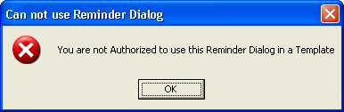

## 4.5 Enable notification for critical lab results, abnormal image results, etc.

Unless enabled at a higher level, various notification types need to be enabled per user as seen from CPRS Tools menu, Options, Other CPRs parameters, and then Notifications tab as below:

This is appropriate to the type of alert required. Critical labs results (action) and Abnl Imaging Reslt, Need Attn (action) need to be turned on for the test examples provided.

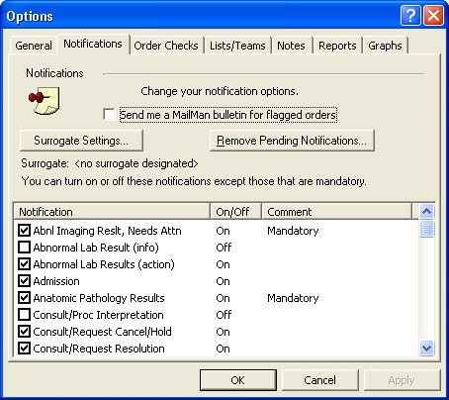

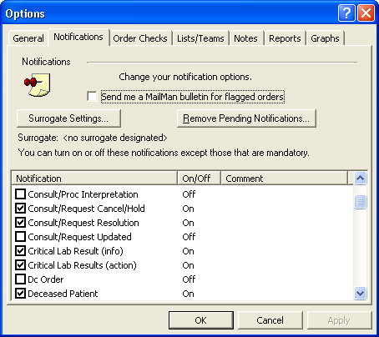

Other User’s settings

* Assign a user the ORES security key to be able to write orders as a provider.
* Provide a user sufficient USR/ASR user subscription role for creating/editing/and signing progress notes.
* Assign PROVIDER user class if necessary.
* Set a user’s AUTHORIZED TO WRITE MED ORDERS field in the NEW PERSON file to “YES”.
* Assign a user a New Person class such as Physicians (M.D and D.O.) with an effective date of service.
* A user electronic signature is needed to this provider to be able to sign orders and notes.

# Testing

## 5.1 Generating Critical Lab and Abnormal Imaging Result Alerts

1. Assign these options for a Lab technician or Radiologist to make alerts on behalf of a provider (but without an order for that alert)

ABIM Critical Abnormal Imaging Results Alert [**VEFA ENTER IMAGING ALERT**]

CRLA Enter lab data for VEHU patients [**ZVHVEHU LAB DATA ENTRY]**

1. Provide a Lab tech user having at least the security keys below:

**LRLAB LRLIASON LRSUPER LRVERIFY ORELSE**

1. Load and install the ZVH_1_1.KID
2. Load and install the ZVH_1_2.KID
3. Make a critical lab test alert below for PROSTATE SPECIFIC ANTIGEN and OCCULT BLOOD.

*Assuming OCCULT BLOOD and PROSTATE SPECIFIC ANTIGEN are in the ORDERABLE ITEMS file and LABORATORY TEST file for generation of lab alerts below.

A. Logon as this Lab Tech user who will make critical lab alerts for other providers.

B. Create alert for Prostate Specific Antigen (PSA)

Select OPTION NAME: **ZVHVEHU LAB DATA ENTRY** Enter lab data for VEHU patients

Enter lab data for VEHU patients

Select LABORATORY TEST NAME: **PSA**  **PROSTATE SPECIFIC ANTIGEN** PSA

Is BLOOD GOLD TOP the correct sample to collect? Y//

Reference Ranges for this test and Specimen:

Reference Low: 0.1

Reference High: 4.0

Critical Low: 0

Critical High: 15

If you want the same value for all patients, enter it for both high and low

Enter the low result to enter for this test: **16** **🡨 greater than 15**

Enter the high result for this test: **18**  **🡨 greater than 15 so that any randomly selected value(s) between 16 and 18 are all > 15 as a Critical High value.**

Enter the date/time of collection for all results: **NOW**  (AUG 18, 2011@00:37)

Provider Selection:

Select a Provider: CLI

1 CLINCOORDINATOR,FIVE FC

2 CLINCOORDINATOR,FOUR FC

3 CLINCOORDINATOR,ONE OC

4 CLINCOORDINATOR,THREE TC

5 CLINCOORDINATOR,TWO TC

Press <RETURN> to see more, '^' to exit this list, OR

CHOOSE 1-5: **1 CLINCOORDINATOR,FIVE** FC **🡨 or select other provider** **like PROVIDER,EIGHT**

Select patients to enter the selected lab result for. Select numbers between 0 and 950 with the number corresponding to the VeHU patient that you want to update. **For example, choosing number 12 will update VeHU patient twelve (LAST 6 digits of SSN. Test patients SSN assumed XXX and leading zeros up to 6 digits OR ""XXX00"_"L4.".L4 as last four. Twelve is with a patient with SSN XXX000012**

Select patient(s) to be updated: (0-950): **12** **🡨 enter last part of SSN**

Are you ready to proceed? **YES**

TWELVE,PATIENT 4-7-35 666000012 YES SC VETERAN SMB

SMB

Enrollment Priority: Category: IN PROCESS End Date:

PROVIDER=CLINCOORDINATOR,FIVE

LAB Order number: 17657

ACCESSION: JMS 11 13 <7811000013>

PROSTATE SPECIFIC ANTIGEN BLOOD SERUM

GENERAL PROCESSING INST.: This test can be processed for outside labs, as

well as in house

ACCESSION: JMS 11 13

8/18 00:37d

PROSTATE SPECIFIC ANTIGEN 13 H* u/mL

Verified!

************************************************

C. Create Alert For FOBT (Occult Blood)

Select OPTION NAME: **ZVHVVEEHU LAB DATA ENTRY** Enter lab data for VEHU patients

Enter lab data for VEHU patients

Select LABORATORY TEST NAME: **OCCULT BLOOD** OCC BLD

The Sample Is STOOL

Reference Ranges for this test and Specimen:

Reference Low: "NEG."

Reference High: "POS"

Critical Low:

Critical High: .1

If you want the same value for all patients, enter it for both high and low

Enter the low result to for this test**:.2** **🡨enter higher than .1**

Enter the high result for this test: **.3** **🡨enter higher than .1**

Enter the date/time of collection for all results**: NOW** (AUG 21, 2011@11:17)

Provider Selection:

Select a Provider: CLI

1 CLINCOORDINATOR,FIVE FC

2 CLINCOORDINATOR,FOUR FC

3 CLINCOORDINATOR,ONE OC

4 CLINCOORDINATOR,THREE TC

5 CLINCOORDINATOR,TWO TC

Press <RETURN> to see more, '^' to exit this list, OR

CHOOSE 1-5: **1 CLINCOORDINATOR,FIVE** FC **🡨 or select other provider** **like PROVIDER,EIGHT**

Select patients to enter the selected lab result for. Select numbers between

0 and 950 with the number corresponding to the VeHU patient that you want to

update. For example, choosing number 12 will update VeHU patient twelve

(LAST 6 digits of SSN. Test patients SSN assumed XXX and leading zeros up to 6 digits or "XXX00"L4. L4 as last four

Twelve is XXX000012 for SSN)

Select patient(s) to be updated: (0-950): **7 🡨 enter last part of SSN**

Are you ready to proceed? **YES**

SEVEN,PATIENT 4-7-35 666000007 YES SC VETERAN

Enrollment Priority: GROUP 3 Category: IN PROCESS End Date:

PROVIDER=CLINCOORDINATOR,FIVE

LAB Order number: 17659

ACCESSION: URINE 0821 2 <2112330002>

OCCULT BLOOD STOOL FECES

ACCESSION: URINE 0821 1 URINE 0821 2

8/21 10:47d 8/21 11:17d

OCCULT BLOOD POS POS H*

Verified!

************************************************

1. Make an Abnormal Imaging Result Alert for a Chest X-Ray and Mammogram
2. Provide a Radiologist (user) having the following options and security keys below,

**[RA RPTVERIFY] Verify Report Only**

**[RA RPTDISP] Display a Rad/Nuc Med Report**

**[RA RPTONLINEVERIFY] On-line Verifying of Reports**

**[RA DAIUVR] Unverified Reports**

**[RA RPTENTRY] Report Entry/Edit**

Keys Held

**MAGDISP CLIN ORES PROVIDER RA ALLOC**

**RA VERIFY**

1. Logon to as this Radiologist user who will make abnormal imaging alert(s) on behalf of another provider.
2. Create Abnormal Imaging alert

Select OPTION NAME: **VEFA**

1 VEFA ALERT TRACKING REPORTING FAT Alert Tracking Reporting

2 VEFA ENTER IMAGING ALERT Critical Abnormal Imaging Results

CHOOSE 1-8: **2**  VEFA ENTER IMAGING ALERT Critical Abnormal Imaging Results Alert

Critical Abnormal Imaging Results Alert

Select Patient for Imaging Alert : **FIVE,PA** **🡨---select patient**

1 FIVE,PATIENT 4-7-35 666000005 YES SC VETERAN

CHOOSE 1-5: **1** FIVE,PATIENT 4-7-35 666000005 YES SC VETERAN

Enrollment Priority: GROUP 3 Category: IN PROCESS End Date:

Provider Selection:

Select a Provider: CLINC

1 CLINCOORDINATOR,FIVE FC

2 CLINCOORDINATOR,FOUR FC

3 CLINCOORDINATOR,ONE OC

4 CLINCOORDINATOR,THREE TC

5 CLINCOORDINATOR,TWO TC

CHOOSE 1-5: **1**  CLINCOORDINATOR,FIVE FC **🡨 Enter on behalf of a provider, in this case, CLINCOORDINATOR,FIVE**

DO YOU WANT CHEST 2 VIEWS PA&LAT? Yes// N (No) or (Yes) **🡨 choose this one**

DO YOU WANT MAMMOGRAM BILAT? Yes// Y (Yes) or (No) **🡨 or choose this one**

## Testing for Follow-up actions upon Patient Chart Closeout.

* + 1. **Prompting for Follow-up action through directed appropriate Reminder Dialog or Signing orders to complete Follow-up actions**

After a test critical alert(s) is made on behalf of a provider, log on CPRS under that user, then select a patient associated with the critical alert. Upon a Patient Chart Closeout when doing a New Patient selection, a screen similar to that below will present. This is a Follow-up Action Tracking (FAT) alert prompt which provides direction to bring up a Reminder Dialog automatically on behalf of the user:

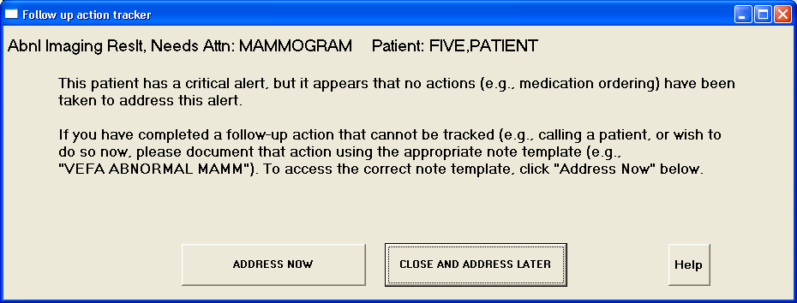

Clicking the “Address Now’ button will automatically bring up the appropriate TIU Template/Reminder Dialog.

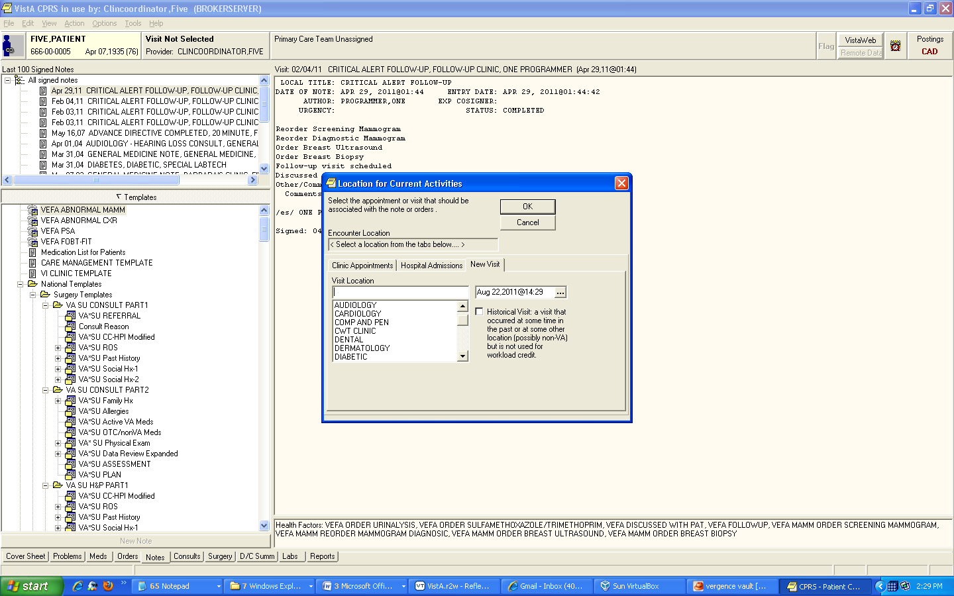

After TIU Template is auto-selected, a Location prompt for New Visit is automatically presented with clinic choice. Choose appropriate clinic. Example below is Follow-up clinic, but this could be any Provider’s clinic.

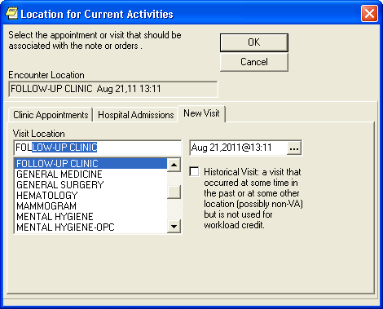

Next select appropriate Progress Note Title.

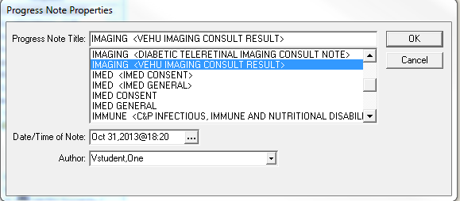

Then Reminder Dialog should appear as below:

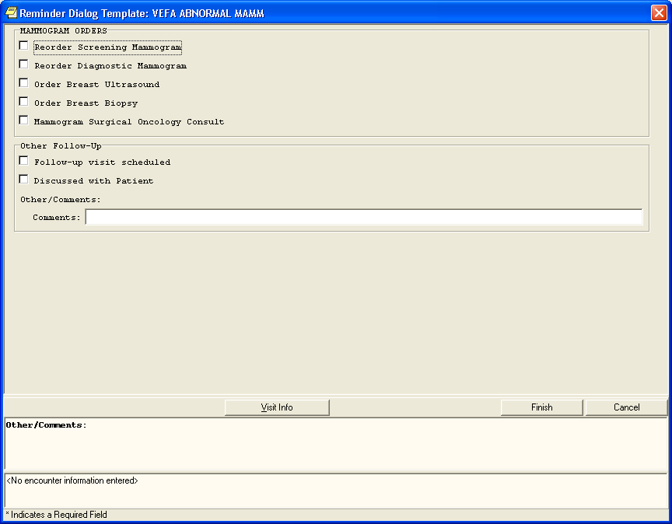

If follow-up action is not made a patient closeout will initiate the FAT prompt again.

To bypass FAT prompt again at Patient closeout, click and sign all appropriate orders and/or click any other follow-up actions.

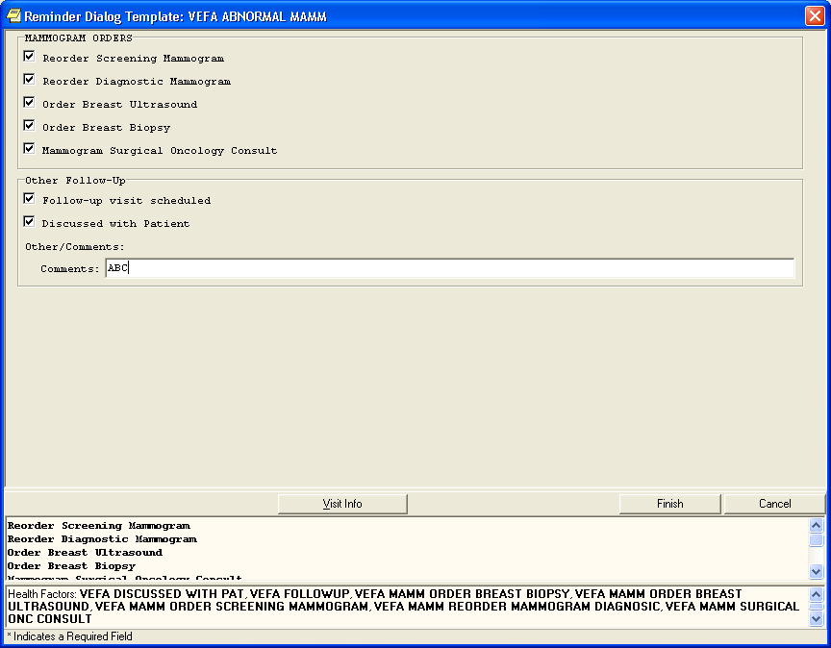

These can be orders or non-order follow-up actions. Use ‘VEFA’ named orderable items for some procedures.

If no order follow-up actions are clicked, but other non-order follow-up actions are, these actions will still allow bypass of FAT prompt on next Patient Chart Closeout.

Click the “Finish” button to initiate follow-up actions.

ORDERS and other Follow-up actions stored in the progress note should follow.

Sign note and orders is required to allow bypass of FAT prompt on a Patient Chart Closeout. This also allows acknowledge/deletion of the alert without a renewal. See additional in next section Test 2: Testing with Alert Acknowledge/Deletion with or with an Auto-Renewal.

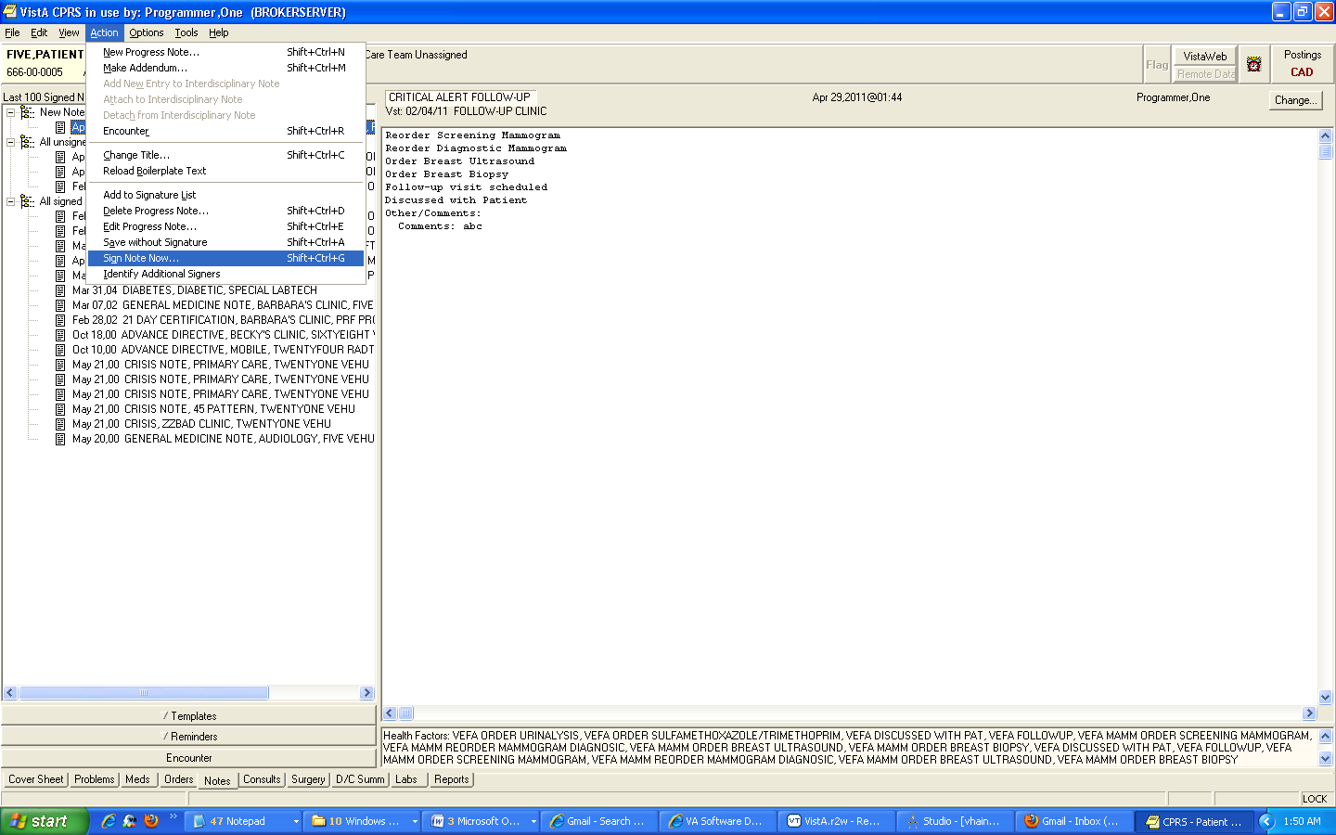

Diagnosis and service connected conditions may be required upon signing of orders.

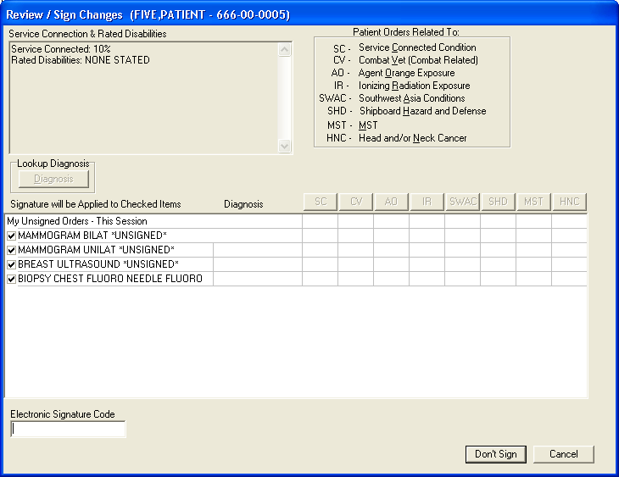

Pertinent Orders to satisfy Follow-up Actions do not have to be made through the “Address Now” button from a FAT prompt on Patient Chart Closeout . These can be done independently, and when completed will present no need for any future FAT prompting.

THE FAT prompt is for the most recent critical alert for a patient needing follow-up action. As soon as the Follow-Up Action of this most recent alert is completed, any next most recent unacknowledged FAT type alert will prompt provided there is needed Follow-up Action. And the process is continued for this alert, and so on.

If unsigned orders still exist, a Patient Chart Closeout is presented with FAT prompt as below:



Clicking “Address Now” will automatically go to the “Orders” tab.

## Testing with Alert Acknowledge/Deletion with an Auto-Renewal

When Follow-up actions have not been completed upon a Patient Chart Closeout, a FAT prompt appears as below:

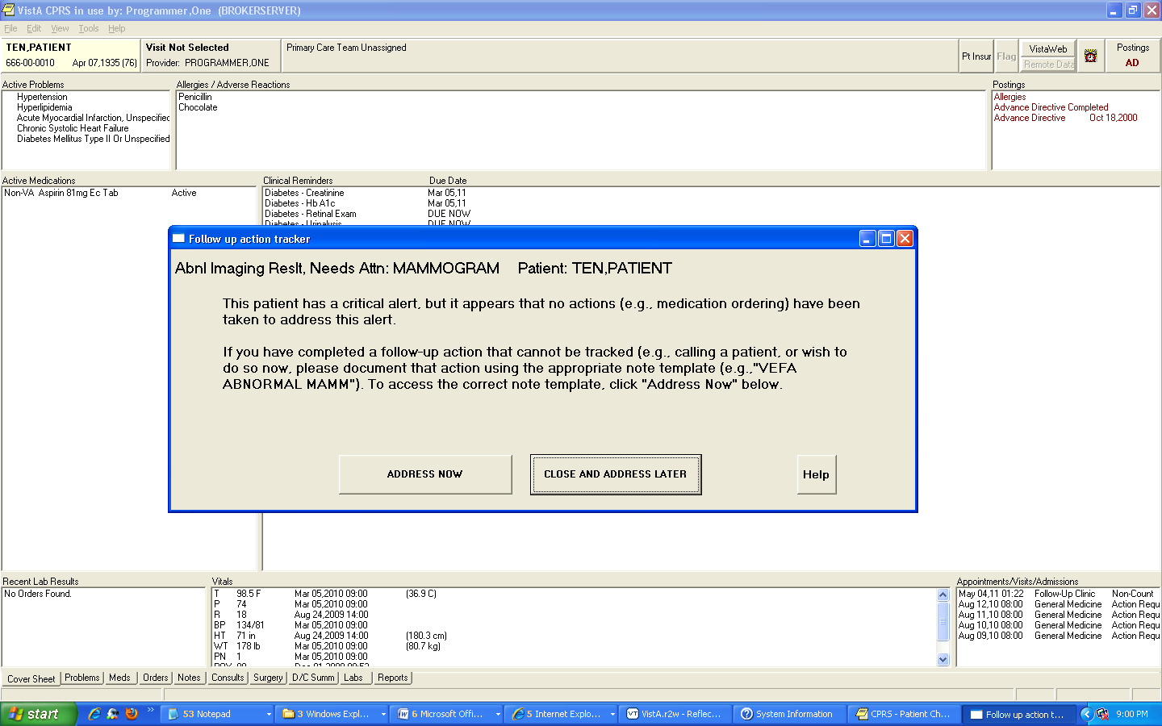

Enter close and address later. Try to acknowledge Abnormal Mammogram Alert.

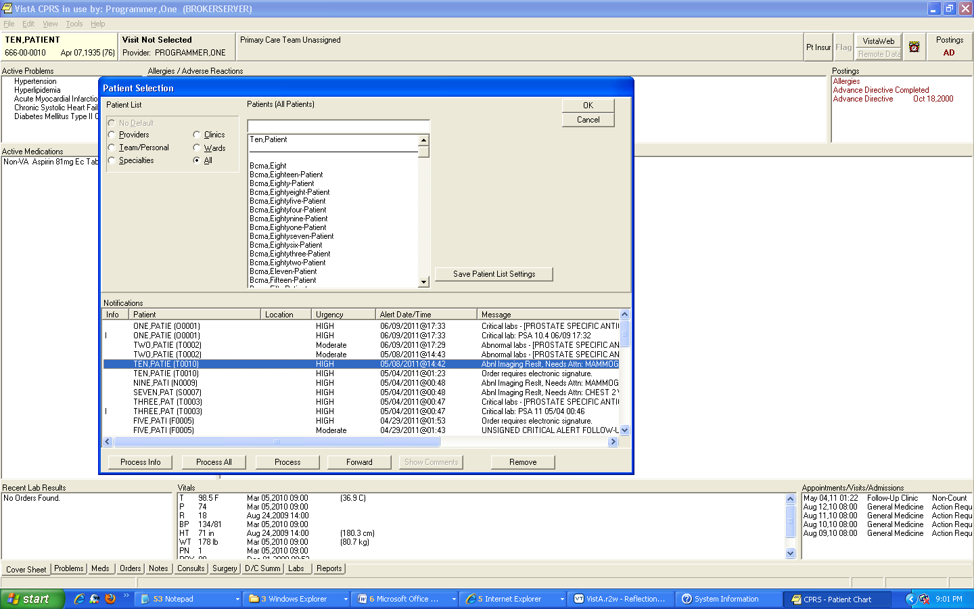

Acknowledging the alert with the “Process” button will cause renewal of the alert.

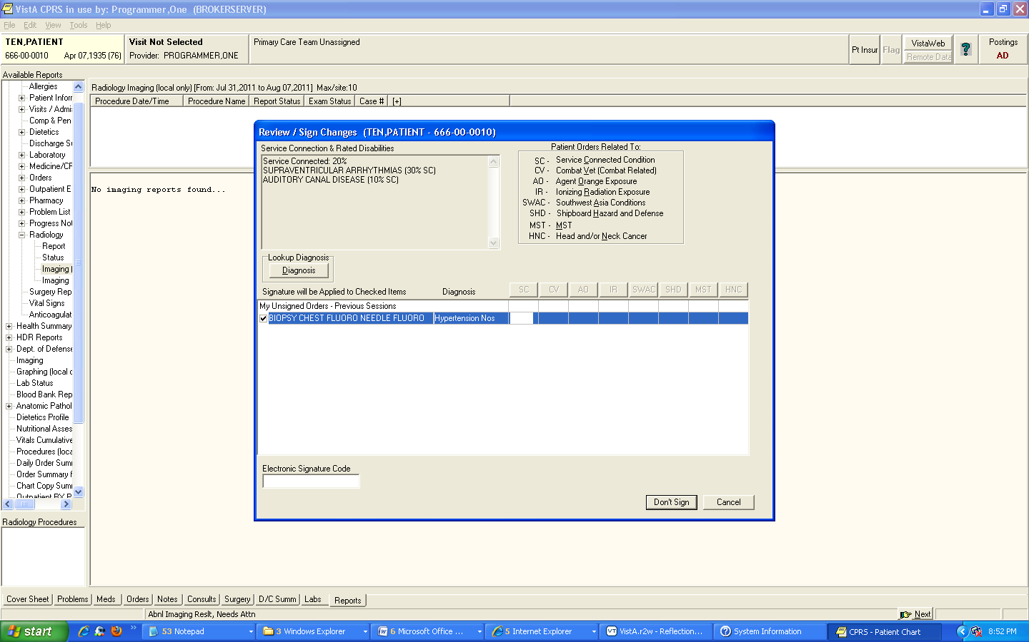

Doing another Patient Chart Closeout presents a FAT prompt again, meaning the acknowledged/deleted alert was automatically “renewed” .

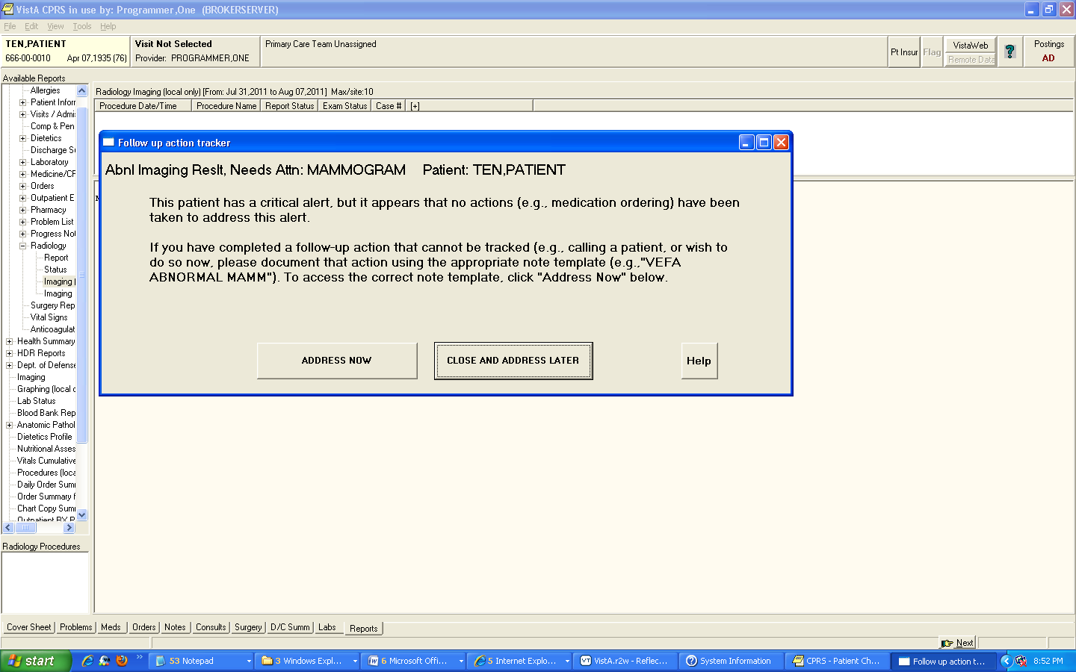

Click Close and Address later button to show alert list for provider.

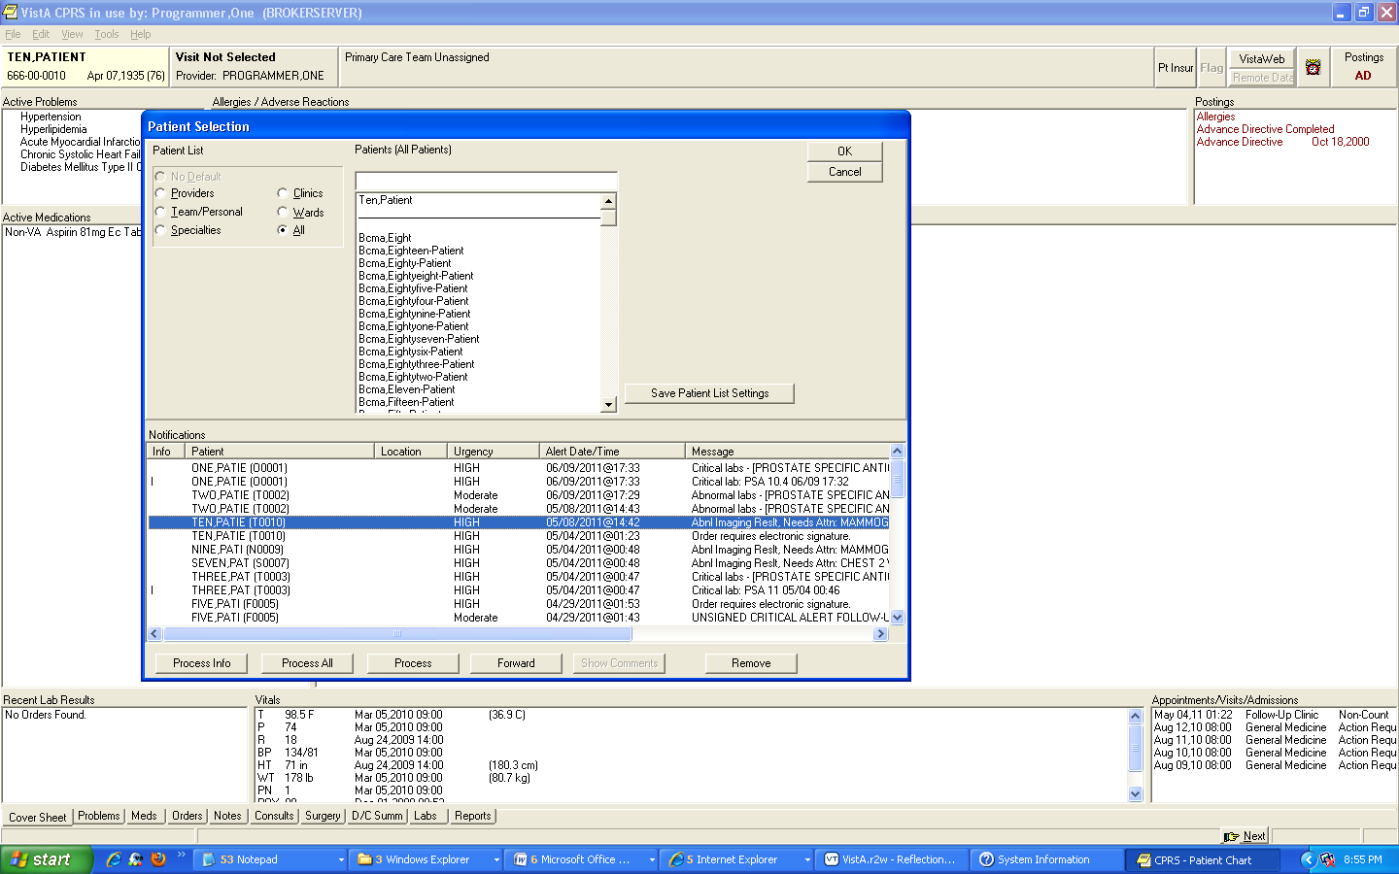

Same Alert is display as a Renewed Alert.